**Kol simcha torah gazette**

**For parshas vayeira 5784**

Volume 8 Issue 8 (Whole #366) 20 Mar Cheshvon 5784/ November 4, 2023

**Printed L’illuy nishmas Nechama bas R’ Noach, a”h**

For a free subscription, please forward your request to [***keren18@juno.com***](mailto:keren18@juno.com)

***Past emails can be found on the website ShabbosStories.com under Brooklyn Torah Gazette***

**Overcoming the Hamas Threat with the Awesome**

**Power of Tefilla (Prayer)**

**By Daniel Keren**



**Rabbi David Ozeri**

On October 22nd, a large Asifa on behalf of our Acheinu Benei Yisroel (our Jewish brothers and sisters in Eretz Yisroel) was held in Flatbush outside Rav Landau’s Shul that brought close to two thousand Jews to hear inspiration of prominent rabbis and the recitation of Tehillim. One of the two rabbis who delivered Divrei Hisororis was Rabbi David Ozeri, a well-known Syrian askan who is one of the dynamic spiritual leaders of the Ocean Parkway synagogue Yad Yosef.

In his words of chizuk to a Flatbush community that like other kehillahs around the world are still in shock over the most barbaric massacre of Jewish civilians since the Holocaust, Rabbi Ozeri said that we Jews have one potent weapon if only we will take the time to utilize.

**The Power of Tefilla or Prayer**

That weapon of course is that of Tefilla or Prayer. Rabbi Ozeri argued at the Flatbush Asifa on behalf of our embattled Jewish brethren in Israel [and in truth on behalf of all in every part of the world that is endangered by the massive outbreak of anti-Semitic protests in major cities around the world including Manhattan and Downtown Brooklyn.

The major problem that Rabbi Ozeri warned those attending the Asifa was our own failure to not appreciate the gift that G-d has given every Jew – the ability to connect with our Father in Heaven by sincere tefilla. Every Jew has the ability to speak sincerely and heartful love to Hashem three times a day, but all too often waste this precious opportunity because of our “sin” of just praying by rote. His suggestion was to just add one minute to the most important prayer – the Amidah or Shemonah Esrai.

Rabbi Ozeri pointed out that there are 19 blessings in the Amidah plus as the end the Elokai Nitzor. All we have to do, he said was take three seconds before each blessing and glance at the words to know what we are saying. That adds to exactly one minute and if we all do that we can connect to G-d and demonstrate that we truly believe that everything is in his power to obliterate the evil of Hamas and save His beloved people from their threats of annihilation of the Jews in Israel and around the world.

**What was Chizkiyahu’s Terrible Sin?**

As an example of the efficacy of tefilla, Rabbi Ozeri spoke at the Flatbush Asifa of Chizkiyahu Hamelech, a descendant of King David who was very sick on his death bed. The Prophet Yishayahu (Isaiah) comes to tell the king of Yehuda “to set your house in order for you will die and not live.” Stunned by the proclamation that he will not only die in this world but will not live in the World to Come, Chizkiyahu asks the prophets what sin he had committed to deserve such a terrible fate.

Yishayahu declares that Chizkiyahu is being punished by G-d for his failure to bring children into the world. The king tells the prophet that he did so because he had ruach hakodesh that one of his children would be a terrible sinner. Yishayahu says that Chizkiyahu’s job is to fulfill the Torah commandments (including bringing children into the world) and let Hashem worry about the consequences. Chizkiyahu then tells Yishayahu that he will marry the prophet’s daughter and in that merit, perhaps the children he has won’t be so evil.

The prophet tells the king that it is too late and the decree in shomayim that Chizkiyahu must die cannot be averted. In anger the king orders the prophet to leave immediately. Declaring that he has a kabbalah (teaching) from his grandfather (Dovid Hamelech) that even if the sword is on one’s neck, one should pray to Hashem and never give up hope for a redemption from death.

Indeed, Chizkiyahu does so and he is healed and goes on to live for another 15 years. And this is a lesson for all of us to emulate as the threat of not just Hamas, but also of Hezbollah on Israel’s northern border and Iran’s nuclear threats against Israel can be nullified if we just also pray to G-d sincerely.

*Reprinted from this week’s edition of The Jewish Connection.*

**Thoughts that Count**

**for Our Parsha**

*He lifted up his eyes... and behold, three men were standing by him* (Gen. 18:2)

To Abraham the visitors appeared as men, but to Lot they looked like angels. Our ancestor Abraham was generous and kind, welcoming rich and poor into his tent with equal enthusiasm. Lot, by contrast, would only allow important people into his home. Thus, there was no need for the strangers to appear to Abraham as angels, as his hospitality extended to everyone. *(Nifla'ot Chadashot)*

*For I know him, that he will command his children and his household after him* (Gen. 18:19)

According to Rashi, "For I know him" is "an expression of love...for he who knows someone brings him near to himself, and knows him and understands him." Why did G-d love Abraham so much? Unlike other righteous people who lived before his time, Abraham understood that the objective in serving G-d is not to attain individual perfection through contemplation, but to actually have a positive effect on the world. G-d knew that Abraham would "command his children and household after him" to go in the way of the Torah, and thus loved him dearly. *(Our Sages)*

*And Sarah saw the son of Hagar the Egyptian...laughing* (Gen. 21:9)

As Rashi explains, the word "laughing" in this context denotes "idol worship, illicit relations and murder." To a wicked person like Ishmael, even the gravest sins were a big "joke." Isaac, however (whose Hebrew name Yitzchak is derived from the same word meaning "to laugh"), laughed at the petty stratagems of the Evil Inclination... *(Chidushei HaRim)*

*Reprinted from the Parshat Vayeira 5761/2000 edition of L’Chaim.*

**Rav Avigdor Miller on**

**Making People Think that You Are Better than You Really Are**

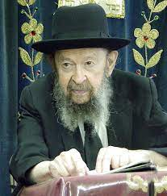

**QUESTION:** Many times, the Rav has advocated here that a person should demonstrate good character, even though he doesn’t really have good character. You said tonight that a man should always act like a fine gentleman even though he isn’t.

**ANSWER:** But isn’t that just plain wrong because we’re deceiving people?

Keep on deceiving them! If you can deceive your wife for the next seventy years into thinking that you’re a nice fellow, then deceive her. You do whatever you can, all day long, to make her think that you’re a wonderful fellow, a gem of a person.

And when it comes to the next world, she will say, “Oh, he was such a wonderful husband.” So, they’ll say, “He wasn’t such a fine fellow.” So, she’s says, “No! He was wonderful, a wonderful husband!” And Hashem will take her word for it. Hashem will say, “I’ll take your word for it.”

So, you keep on deceiving everybody – and not only your wife but everybody – and Hakodosh Boruch Hu will reward you for it. Now, that doesn’t mean that you should say that you’re a fine fellow, no. But you should always act like a fine fellow, and Hakodosh Boruch Hu will reward you for that.

*Reprinted from the Parshas Lech Lecha 5784 email of Toras Avigdor based on Tape #920 (July 1993).*

**Utilizing our Exile Now as a Proper Preparation for the**

**Coming Messianic Era**

**From the Teachings of the Lubavitcher Rebbe**

**Rabbi Menachem Mendel Schneerson, Zt”l**



Our Sages explain the verse in this week's Torah portion, Vayeira, "Abraham was old and well advanced in age," to mean that Abraham utilized every day of his life in the service of G-d. Not one day of his life span on earth was deficient.

We are also told, however, that Abraham did not recognize the Creator until the age of three. (Other statements in the Midrash cite different ages, 40 and 48 respectively, at which Abraham recognized the One true G-d.) How then can our Sages have said that all of Abraham's days were spent in Divine service, when there was obviously some length of time (depending on the interpretation) before he came to worship G-d properly?

In truth, the same question can be asked of each and every individual Jew. The obligation to observe the Torah's commandments begins only at the age of 13, or 12 for girls. Does this mean that before the age of Bar of Bat Mitzva, when a child is first learning about Torah and mitzvot, that his service of G-d is somehow imperfect?

Not at all. A child's formative years of Jewish education are not only not considered deficient in any way, but are an integral part of the preparation necessary for living a full adult life. When a child is taught how to observe Torah and mitzvot, his childhood is being utilized to its fullest potential. Whenever the Torah commands us to perform a certain action, whatever preparations we need to make ahead of time are also considered part of the mitzva.

One cannot make the argument that the first 12 or 13 years of a Jew's life are spiritually lacking, simply because G-d exempts him from punishment. Rather, it is G-d's will that this period of time be spent learning how to observe Torah and mitzvot most fully in later life.

**The Example of Our Ancestor Abraham**

The same principle can be applied to our ancestor Abraham. True, he only came to recognize G-d at a certain chronological age, but all of the time leading up to this was spent in the pursuit of truth, as Maimonides writes, "His mind began to range...until he perceived the path of truth." Abraham's early years were therefore not flawed, but an important and necessary stage in his Divine service. He may not have perfected his worship of G-d until a certain point, but in terms of utilizing his time and effort to the maximum, he was as perfect as could have been expected of him.

In fact, the entire period of our exile can be considered as preparation for the spiritual perfection we will attain in the Messianic era. But it is precisely now, by "educating" ourselves properly, that we will achieve the very highest levels of perfection with the Redemption.

*Reprinted from the Parshat Vayeira 5761/2000 edition of L’Chaim. Adapted from Volume 35 of Likutei Sichot.*

**Dust and Ashes**

Behold now I have taken upon myself to speak to the L-rd, although I am but dust and ashes. (18:27) All people are but dust and ashes, yet they speak to G-d daily when they pray. Abraham was pointing out that, despite the wickedness and corruption of the people of Sodom, Abraham felt enough compassion for them to pray on their behalf.

Abraham was saying that if he could feel compassion for those people, then so should G-d, Ruler of the universe, grant them mercy and allow them to live. (Reb Bunim of P'shischa)

*Reprinted from the Parshat Vayeira 5784 email of R’ Yedidye Hirtenfeld’s whY I Matter parsha sheet for the Young Israel of Midwood.*

**Rabbi Berel Wein on**

**Parshat Vayeira 5784**

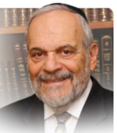

The story of the miraculous birth of Yitzchak to his ninety-year-old mother Sarah is not only one of the highlights of the parsha but it is one of the foundation narratives of all of Jewish history. Without Yitzchak there simply isn’t a Jewish people. The birth of Yitzchak is one of the triumphal moments of Jewish life, a reflection of G-d’s mercy and guidance in creating His special people.

It is therefore all the more surprising – indeed shocking – that the story of Avraham sacrificing Yitzchak appears in this very same parsha. In effect, this story of the binding of Yitzchak on the altar of Mount Moriah completely negates the miraculous birth of Yitzchak. Of what necessity or purpose is the miracle of Sarah’s giving birth to Yitzchak if the entire matter will be undone by the succeeding story of Avraham sacrificing Yitzchak? What is the point that the Torah wishes to teach us by unfolding this seemingly cruel sequence of events? Is not G-d, so to speak, mocking His own Divine Will and plans by this sequence of events, recorded for us in this most seminal parsha in the Torah?

Much ink has been used in dealing with this most difficult issue. It has been the subject of much commentary in Midrash and Jewish thought throughout the ages. Amongst the many mysterious and inscrutable issues that G-d raises for our analysis in His Torah, this contradiction between the miraculous birth of Yitzchak and the challenge of his being bound on the altar ranks high on that long list of Heaven’s behavior that requires Jews to have faith and acceptance.

 But is this not the nature of things in today’s Jewish world as well? After the most negative of extraordinary events of sadistic cruelty that we call the Holocaust, miraculous positive events have occurred to the Jewish people. The old woman of Israel, beaten and worn, was revived and gave birth to a state, to a vibrant language, to myriad institutions of Torah learning and good deeds, to the miraculously successful ingathering of the exile communities to their homeland, to a scale of Jewish affluence unmatched in Jewish history.

In short, the story of the Jewish people in its resilient glory over the last seventy-five years defies rational and easily explained historical logic. And yet the danger and tension of open hostility to the State of Israel, the threats to its very existence, the attempts to delegitimize it and boycott its bounty, all are evident in our current world.

In the story of Yitzchak, the Torah teaches that we have to live in a world of almost absurd contradictions. Logic plays a very small role in the events of history that occur to the people of Yitzchak. Yitzchak is a product of miracles and his very maturation and survival is also a product of supernatural stuff. So too is this the story of the Jewish people in our age. Just as Yitzchak survived and proved successful, so too shall we, his progeny, survive and be successful and triumphant.

Shabbat shalom

*Reprinted from the current website of rabbiwein.com*

*\*\*\*\*\*\*\*\*\*\*\*\*\*\*\*\*\*\*\*\*\*\*\*\*\*\*\*\*\*\*\*\*\*\*\*\*\*\*\*\*\*\*\*\*\*\*\*\*\*\*\*\*\*\*\*\*\*\*\*\*\*\*\*\*\*\**

“For I have loved him, because he will instruct his children and his household after him to keep the way of Hashem . . .” (18:19) After all that Avraham did–allowing himself to be thrown into a furnace, leaving his homeland, etc.–the attribute that Hashem loves most about Avraham is that he will instruct his children to keep the way of Hashem!

This demonstrates, says R’ Aryeh Levin z”l (1885-1969; known as the “Tzaddik of Yerushalayim” and as the “Father of the Prisoners” for his role as chaplain of the Yerushalayim prison), that all of Avraham’s and our own tests and challenges are meaningful only if we successfully transmit our beliefs to the ensuing generations. (Brito Le’hodi’am)

*Reprinted from the Parshat Vayeira 5784 email of R’ Yedidye Hirtenfeld’s whY I Matter parsha sheet for the Young Israel of Midwood.*

**Why Is Challah Braided?**

**By**[**Yehuda Shurpin**](https://www.chabad.org/search/keyword_cdo/kid/15169/jewish/Shurpin-Yehuda.htm)

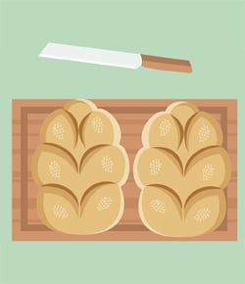

***Art by***[***Sefira Lightstone***](https://www.chabad.org/3159160)

Technically, the Shabbat (and holiday) meal can be started with any two whole loaves of kosher bread. In fact, the word *challah*simply means “loaf” in Hebrew. However, the long-standing Jewish custom is for these breads to be braided.

**The Twelve Loaves of the Temple**

In the hymn sung by many during the Shabbat meal and composed by the great mystic Rabbi Yitzchak Luria, known as the Arizal, we read:

*May the Shechinah (“Divine Presence”) be surrounded*  
*by the six loaves on each side [of the table];*  
*and may they correspond to the two sets of six loaves*  
*and the other articles [of the Holy Temple] . . .*

In other words, we are praying that our 12 loaves of [challah](https://www.chabad.org/theJewishWoman/article_cdo/aid/323423/jewish/Taking-Challah.htm) evoke the [12 showbreads](https://www.chabad.org/library/article_cdo/aid/2974301/jewish/The-Showbread-The-How-and-Why-of-the-Temple-Bread-Offering.htm) that were placed on the Table (Shulchan) in the Holy Temple.

Some people make a point of placing 12 breads on their Shabbat tables or using a “pull-apart challah” made of 12 mini rolls. But most of us have just two loaves—so how do we arrive at the number 12?

The challah loaf is generally oblong, resembling the Hebrew letter *vav,*which has the numerical value of six, so the two loaves would equal 12.[1](javascript:doFootnote('1a480266');) Many also braid each challah loaf with six strands,[2](javascript:doFootnote('2a480266');) also bringing the total to 12.[3](javascript:doFootnote('3a480266');)

Since the 12 showbreads were replaced every week on Shabbat, the custom to use oblong or braided challahs applies to Shabbat, whereas during the holidays, there are various different customs. For example, during the High Holidays, [round challah is preferred](https://www.chabad.org/library/article_cdo/aid/3786536/jewish/Why-Is-Rosh-Hashanah-Challah-Round.htm).

**Meaty Bread**

Since bread is commonly eaten together with either meat or dairy, Jewish law forbids either meat or dairy ingredients to be placed into ordinary loaves of bread, as a precaution. This applies even if one is planning to eat the dairy bread with dairy foods or the meat bread with meat foods, since there may be leftovers.

There are some exceptions, however, and meat or dairy may be mixed into bread if either a) the loaves are very small and there is no fear of leftovers, or b) they are made in a unique shape and will be immediately recognized as either meat or dairy.

Since challah bread for Shabbat was regularly baked in the oven together with meat (and sometimes even flavored with fats), people would braid them, so that they would be visually different from [parve bread](https://www.chabad.org/library/article_cdo/aid/3694185/jewish/What-Is-Parve-Pareve.htm), which may be eaten with both meat and dairy.[4](javascript:doFootnote('4a480266');)

(Note: Since it has become common to bake braided challah without meat ingredients (perhaps based on the other reasons listed here), braiding would no longer be a solution to bake an actual meat challah.)

**Reserved for the Day**

The sages explain that the Shabbat day meal is to be more honored than the night meal. As such, some have the custom to only use braided challah for the day meal, honoring it with this unique form of bread.[5](javascript:doFootnote('5a480266');)

**Rectangular Challah: G‑d’s Name**

There are some who don’t braid the challah at all, and rather shape it into rectangular loaves, which evoke the [*vav*](https://www.chabad.org/multimedia/video_cdo/aid/700534/jewish/The-Vav.htm) in [G‑d](https://www.chabad.org/library/article_cdo/aid/433240/jewish/God.htm)’s name. As the mystics explain, the small piece of challah that we first cut off after the *Hamotzi* symbolizes the small letter *yud*, and the two hands (each with five fingers) holding the challah bread correspond to the two *heis*(each numerically equivalent to five), completing G‑d’s name.[6](javascript:doFootnote('6a480266');)

In the merit of honoring the Shabbat, may we merit the “great Shabbat” with the coming of Moshiach!

**FOOTNOTES**

[1.](https://www.chabad.org/library/article_cdo/aid/480266/jewish/Why-Is-Challah-Braided.htm" \l "footnoteRef1a480266) Rabbi Chaim Elazar Schapiro of Munkács (Minchat Elazar) in Chamisha Maamarot, Parshat Emor; see also Likutei Maharich, Seder Seudat Leil Shabbat.

[2.](https://www.chabad.org/library/article_cdo/aid/480266/jewish/Why-Is-Challah-Braided.htm" \l "footnoteRef2a480266) The term used is *keluyot,*which translates literally as “braids” or “twists,” but some understand this to mean “strands.”

[3.](https://www.chabad.org/library/article_cdo/aid/480266/jewish/Why-Is-Challah-Braided.htm" \l "footnoteRef3a480266) Likutei Maharich, Seder Hanhagot Leil Shabbat, Nusach Azamer Bishvachin; Mateh Ephraim 625 and Ktzei Hamateh, *ad loc.*

[4.](https://www.chabad.org/library/article_cdo/aid/480266/jewish/Why-Is-Challah-Braided.htm" \l "footnoteRef4a480266) Chavot Yair in Mekor Chaim 274; see also Pri Megadim 242:1.

[5.](https://www.chabad.org/library/article_cdo/aid/480266/jewish/Why-Is-Challah-Braided.htm" \l "footnoteRef5a480266) See Minhag Yisrael Torah 274:1, who quotes Shelah, who writes that the main time to have 12 challahs is at Shabbat night.

[6.](https://www.chabad.org/library/article_cdo/aid/480266/jewish/Why-Is-Challah-Braided.htm" \l "footnoteRef6a480266) Eliyah Rabah 167:2, quoting the Shelah.

*Reprinted from the current website of Chabad.Org*

**As a Jew in Manhattan, Something Has Changed**

**By**[**Aylin Sedighi**](https://aish.com/authors/573915961)

***Walking the streets of Manhattan today, I am reminded of the fear I felt growing up in Iran.***

I walk down the streets of Manhattan, where I had my first job, where I attended graduate school and where I went on the first date with my husband, and I am terrified. I pass by the graffiti of a swastika on the side of The Second Avenue Deli and tuck in the necklace I am wearing with the Hebrew names of my children.

I send a quick text to my daughter who is a student at a city school and tell her to tuck in her Star of David. She sends me a curt “No”. I smile at her love for her Jewishness, her passion for Israel, and the pride she feels for our people. She got that from me and her father.

**But these days, I am scared.**

The Manhattan I fell in love with over 30 years ago is not the same. Thirty years ago, I was an Iranian refugee and my head spun at the height of the buildings, the colorful people and characters and my mouth melted when I tasted my first New York style pizza. Today I quicken my steps and my eyes are constantly on the lookout.

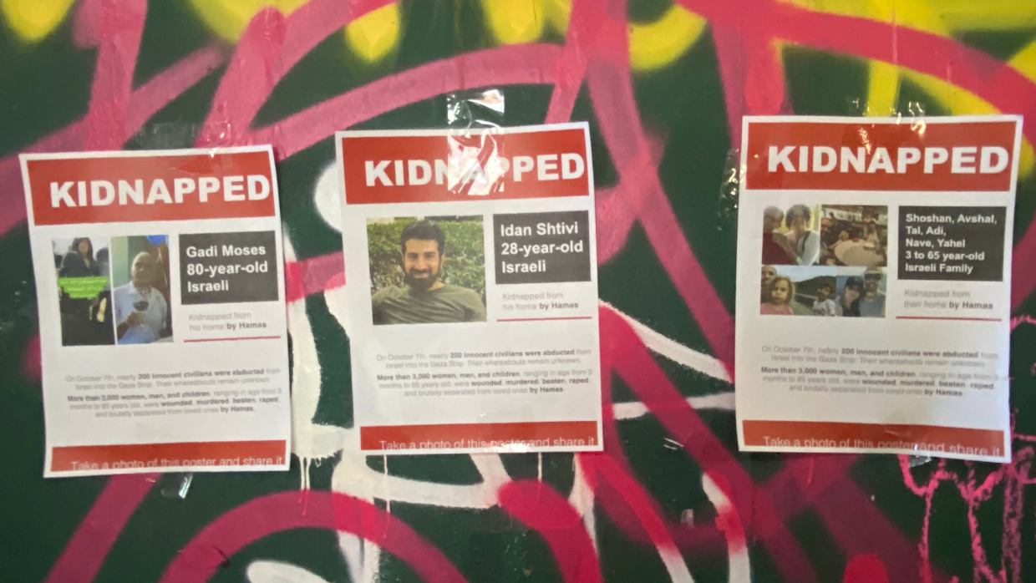

Being a Jew now feels like a bag of mixed emotions, filled with fear, sadness, and outrage, sprinkled with feelings of pride at our unity.

In Iran, I never told anyone I was Jewish if I could help it. My family tried to hide our identity as best as we could, but teachers and neighbors always knew. We were the lone Jewish family on our cul-de-sac, and we kept quiet, interacting with our Muslim neighbors only when absolutely needed. We celebrated our holidays quietly and tried to not draw attention to ourselves in schools or markets.

Once a teacher pointed to me and said to group first graders, “That Jew is a Zionist.” They all looked at me, aghast. I went home and asked my mother what a Zionist was, feeling that it was something terrible. The stories in our school books about the plight of the Palestinian people who longed to returned to their homeland confused me. Wasn’t Israel *my* ultimate homeland?

**Hoping that I Wouldn’t Be Identified as Jewish**

But my parents warned me not to speak up, so I said nothing. I shrank a little more into the wooden bench of my second-grade class, hoping no one would point out the fact I was Jewish. By this time, I considered myself a Zionist, even though I never spoke the words. I knew what the punishment would be for such a declaration.

On my way to school I’d pass by murals depicting Israel and United Stated as the enemy of Islam, slogans of “Death to Israel and America” everywhere. On days of celebrations, or commemoration of deaths of Imams, flags of Israel and America were burned side by side. I can still hear the angry chants of “Death to Israel”, thousands of miles away and some 30 years later. Those words sent a chill down my spine. As a little girl I learned that there are people would want me dead because I am Jewish and love Israel.

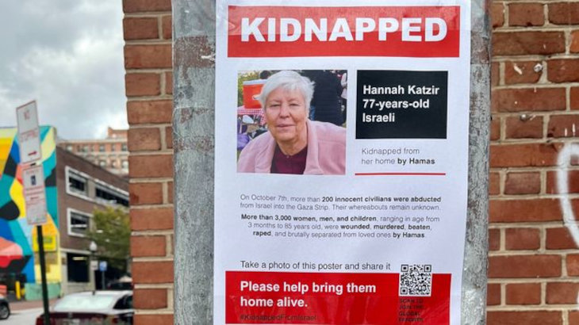

Little did I know that Hamas terrorists with the backing of Iran, would do just that years later, not in Iran, but on the land of the Jewish people. A land where I grew up believing would be a safe haven for all of us. Little did I realize their hate would drive them to commit the worst horrific massacre towards Jews since the Holocaust, shaking the nerve of every Jew around the world.

Walking the streets of Manhattan today, I am reminded of the fear I felt growing up in Iran. When I moved to the United States, I never thought I would have to hide who I am, or be afraid to be Jewish. But history has a way of repeating itself.

In Iran, when passing by the police or a rally, I would pull my head cover around me a little tighter, hoping to be invisible. Now in Manhattan, I hide my Hebrew necklace, feeling guilty to be afraid.

I wonder: Is this how the Jews felt before the Holocaust happened? Is this how my grandfather and father felt walking the streets of Shiraz as angry mobs attacked the ghetto?

Jews are quite familiar with an existential threat. It’s embedded into our genes, and tattooed on our souls like the numbers the Nazis tattooed on their prisoners. Israel is engaged in an existential war, a war that affects all Jews around the world.

The other day my daughter and her friend put up countless flyers about the kidnapped victims of the Hamas terror, demanding their release. Today she calls me, her voice shivering, to tell me they’ve all been taken down. She found some of them ripped up and thrown into trashcans around campus. I am heartbroken for my daughter and for all Jewish students who have to face the reality of hatred towards Jews.

My experience with antisemitism in Iran was not one I ever thought my children would feel in the land of the free. But something amazing has transpired too. These days, my daughters and her friends are attending many rallies, wearing their Jewishness with more pride than ever before. We feel united with Israel, in pain and pride. We are strong and our voices will not be muffled.

*Reprinted from the October 25, 2023 website of aish.com*

*\*\*\*\*\*\*\*\*\*\*\*\*\*\*\*\*\*\*\*\*\*\*\*\*\*\*\*\*\*\*\*\*\*\*\*\*\*\*\*\*\*\*\*\*\*\*\*\*\*\*\*\*\*\*\*\*\*\*\*\*\*\*\*\*\**

“He said, ‘My Master, if I find favor in Your eyes, please do not go away from Your servant’.” (18:3) Rashi z”l writes: He asked G-d to wait for him while he ran to invite the travelers.

R’ Yerachmiel Fried (Rosh Kollel in Dallas, Texas) quotes R’ Shlomo Zalman Auerbach z”l (Yerushalayim; 1910-1995) as observing that Halachah does not permit a person to interrupt Shemoneh Esrei in order to welcome a guest, in contrast to Avraham’s interrupting his encounter with the Shechinah in order to welcome guests.

We are able to learn a lofty principle from Avraham’s action– that welcoming guests is greater than greeting the Shechinah–only because Avraham Avinu lived before the Torah was given and therefore was not obligated to observe Halachah. He could make judgments about which action seemed more important. We, in contrast, do not have that latitude, and our value system must be based on Halachah.

R’ Auerbach adds: We say in the Pesach Haggadah, “If He had (only) brought us close to Har Sinai and not given us the Torah, Dayeinu / for that too we would have been obligated to thank Him.”

What would have been the value of coming to Har Sinai and not receiving the Torah? The answer is that there was a great revelation at Har Sinai. We learn from Dayeinu, however, that having a significant “spiritual experience” is not synonymous with receiving the Torah. (Ma’adanei Shlomo: Mo’adim)

*Reprinted from the Parshat Vayeira 5784 email of R’ Yedidye Hirtenfeld’s whY I Matter parsha sheet for the Young Israel of Midwood.*